| **Test Name** | | Update an Error Type Record | | | |
| --- | --- | --- | --- | --- | --- |
| **Use Case Tested:** | | Use Case – Update an Error Type Record | | | |
| **Test Description:** | | User finds a record entered for an Error Type  User navigates to Search tab and selects Search Error Types, or selects Search Error Types button from welcome page  User is presented with a list of error type records  User searches for an error type using the ID or Error Type fields  User selects record  User amends fields as required  User submits record | | | |
| **Pre-conditions** | | User must be logged in as an administrator  Error Type records must exist | | | |
| **Post-conditions** | | The database is successfully updated with the new data for the Error Type. | | | |
| **Notes:** | |  | | | |
| **Result (Pass/Fail/Warning/Incomplete)** | |  | | | |
|  | **TEST STEP** | | **EXPECTED TEST RESULTS** | P | F |
|  | User selects “Search > Search Error Types” from the menu bar or selects Search Error Types button on Admin Home page | | A list of Error Type records is returned – using tab  A list of Error Type records is returned – using button  *Screenshots available on UAT for Search Error Types* | X  X |  |
|  | User enters a search for an Error Type record | | Records meeting criteria are returned | X |  |
|  | User changes Error Type | | Input does not show error | X |  |

|  |  |  |  |  |  |
| --- | --- | --- | --- | --- | --- |
| **Test Data Table** | | | | | |
|  | **1** | **2** | **3** | **4** | **5** |
| Test – 1 | Search = New | Change to: Incorrect Type |  |  |  |
| Test – |  |  |  |  |  |
| Test – |  |  |  |  |  |
|  |  |  |  |  |  |

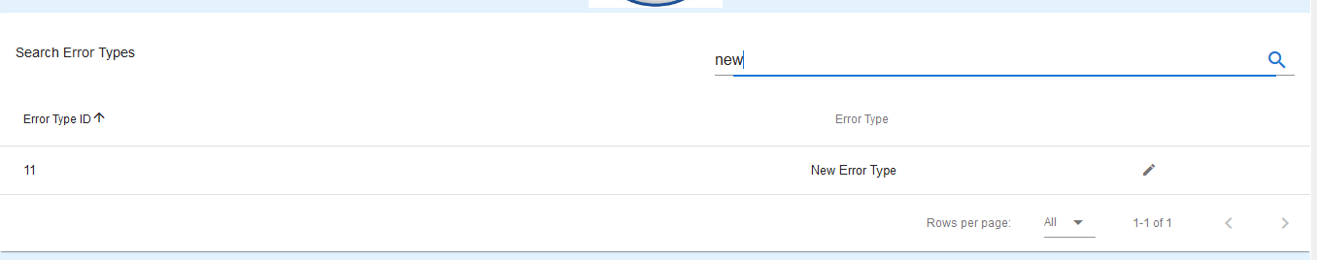

Figure 1: Search results for “new” – Brings up ID 11

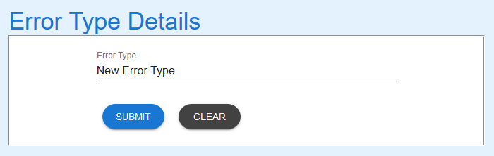

Figure 2: Error Type loaded into Error Type Details

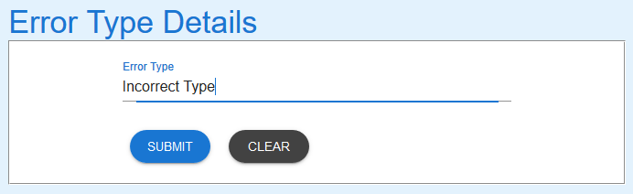

Figure 3: Error Type updated

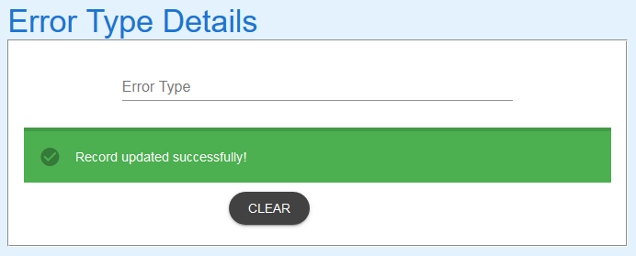

Figure 4:Record submitted. Success message received

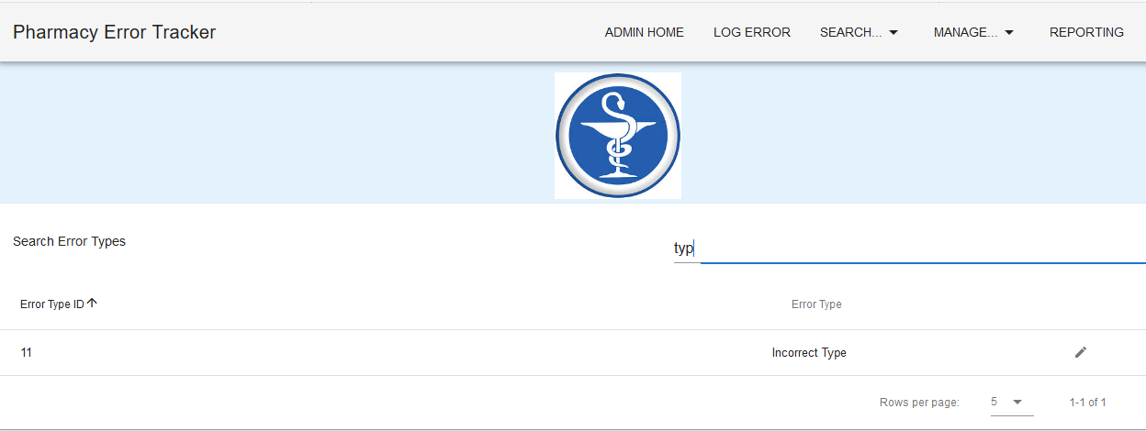

Figure 5: New search for “typ” shows ID 11 has been updated as expected

EXPECTED ERROR MESSAGES:

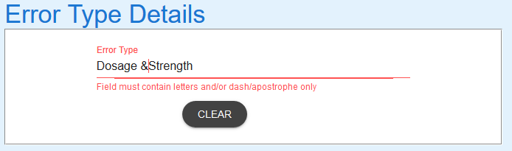 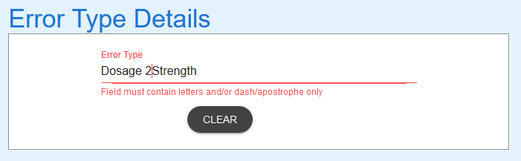

Figure 6: Using a character other than letters, -, or ' (Expected)

EXPECTED BEHAVIOUR  
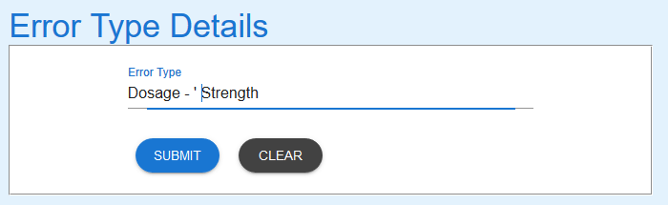

Figure 7: Using - or ' doesn't cause errors – Expected

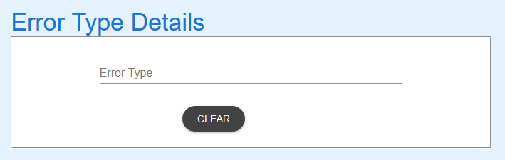

Figure 8: Selecting "Clear" caused form to be cleared – Expected

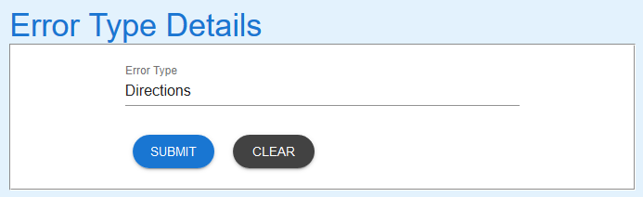

Figure 9: Current Error Type - Directions - to be updated to Other

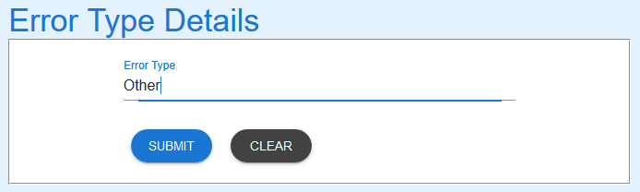

Figure 10: Error Type changed - Submit button selected

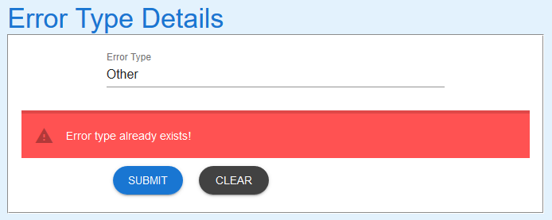

Figure 11: Other exists - Error message as expected

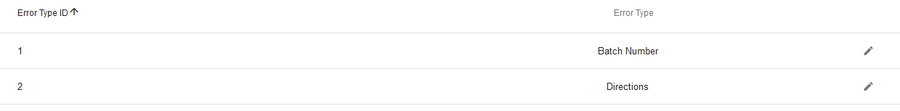

Figure 12: Error type - Directions - not updated. Expected